Activity No. 3.1
Control Structures (part 2)
Course Code: CPE010 | Program: Computer Engineering
Course Title: Data Structures and Algorithms | Date Performed: 8|18|25
Section: CPE11S1 | Date Submitted: 8|18|25
Name(s): Paula Esguerra | Instructor: Engr. Jimlord Quejado
6. Output
- Develop a C++ program that will determine if a department store customer has exceeded the credit limit on a charge account. For each customer, the following facts are available:
  - Account number
  - Balance at the beginning of the month
  - Total of all items charged by this customer this month
  - Total of all credits applied to this customer’s account this month
  - Allowed credit limit
The program should input each of these facts, calculate the new balance (=beginning balance +charges -credits), and determine if the new balance exceeds the customer’s credit limit. For those customers whose credit limit is exceeded, the program should display the customer’s account number, credit limit, new balance and the message “Credit limit exceeded.”

Sample output:
Enter account number (-1 to end): 100
Enter beginning balance: 5394.78
Enter total charges: 1000.00
Enter total credits: 500.00
Enter credit limit: 5500.00
Account: 100
Credit limit: 5500.00
Balance: 5894.78
Credit Limit Exceeded.

Enter account number (-1 to end): 200
Enter beginning balance: 1000.00
Enter total charges: 123.45
Enter total credits: 321.00
Enter credit limit: 1500.00

Enter account number (-1 to end): 300
Enter beginning balance: 500.00
Enter total charges: 274.73
Enter total credits: 100.00
Enter credit limit: 800.00

Enter account number (-1 to end): -1
Program ends.
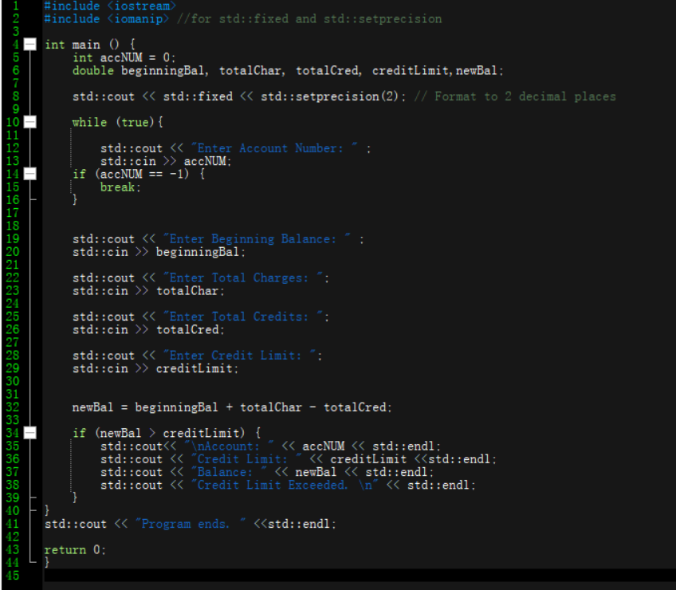

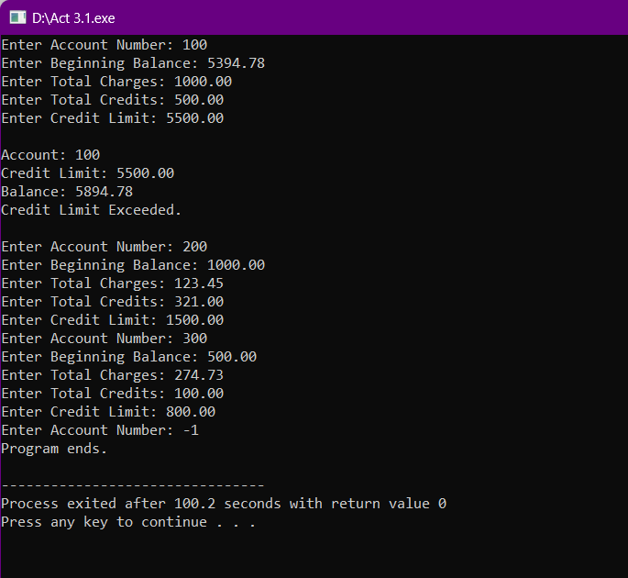

- Because of the price of gasoline, drivers are concerned with the mileage obtained by their automobiles. One driver has kept track of several tankfuels of gasoline by recording miles driven and gallons used for each tankful. Develop a program that will input the miles driven and gallons used for each tankful. The program should calculate and display the miles per gallon obtained for each tankful. After processing all input information, the program should calculate and print the combined miles per gallon obtained for all tank fuels.
Sample output:
Enter the gallons used (-1 to end): 12.8
Enter the miles driven: 287
The miles / gallon for this tank was 22.421875

Enter the gallons used (-1 to end): 10.3
Enter the miles driven: 200
The miles / gallon for this tank was 19.417475

Enter the gallons used (-1 to end): 5
Enter the miles driven: 120
The miles / gallon for this tank was 24.000000

Enter the gallons used (-1 to end):

The overall average miles/gallon was 21.601423
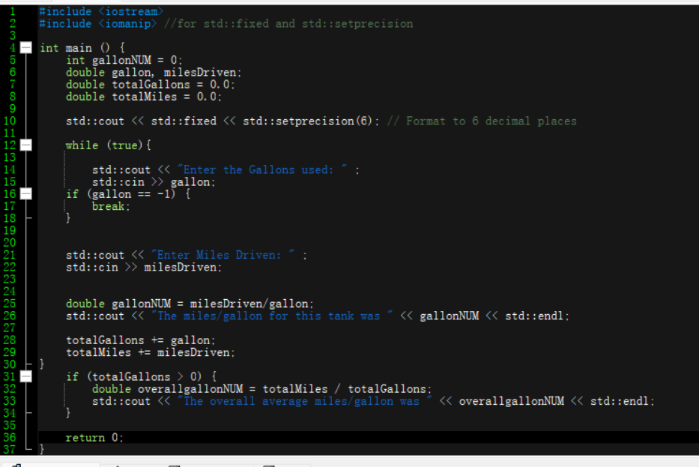

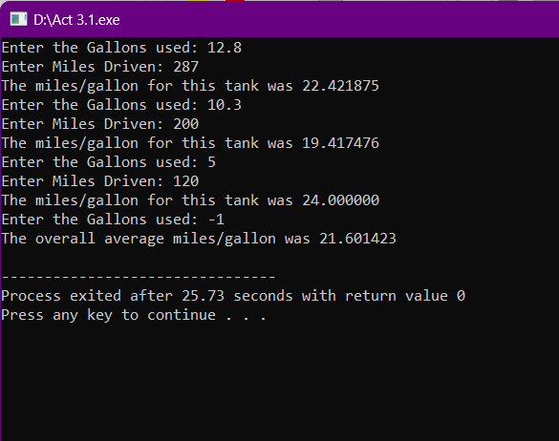

- Create a program that will calculate the cost of sending a small parcel. The post office charges P5.00 for the first 300g, and P2.00 for every 100g thereafter (rounded up), up to a maximum weight of 1000g.
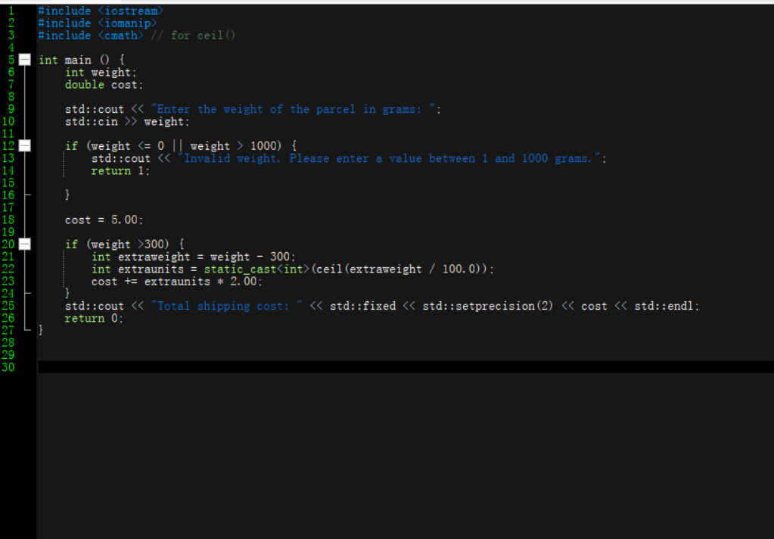

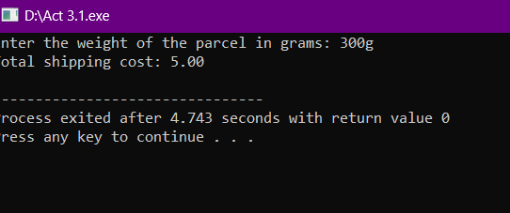

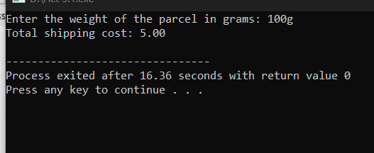

4. Write a program that displays a menu for simple conversion such as the following:
- (1) cm - inches
- (2) inches - cm
- (3) feet - meter
- (4) meter - feet
Once selected, user will be asked to enter a float and be converted. After the conversion the user would be ask to convert another until the user don't want anymore. Display your samples for all conversions
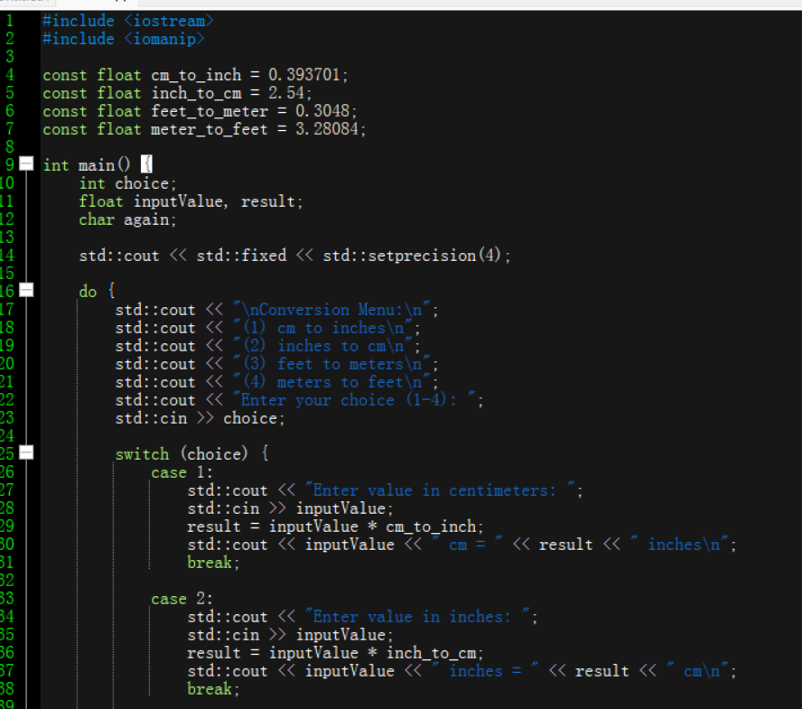

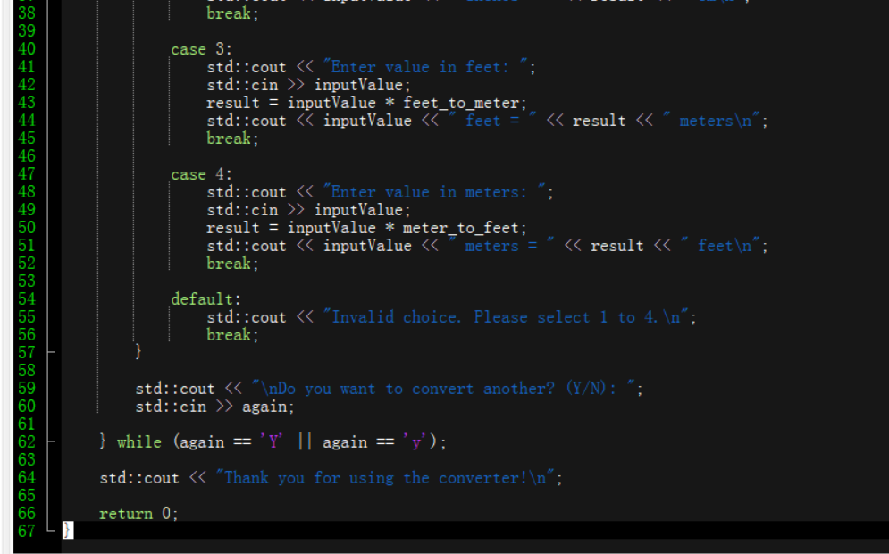

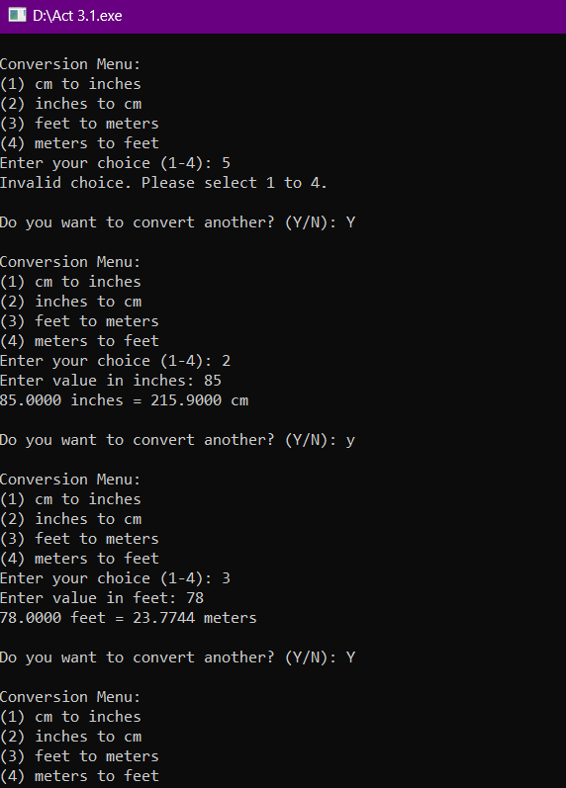

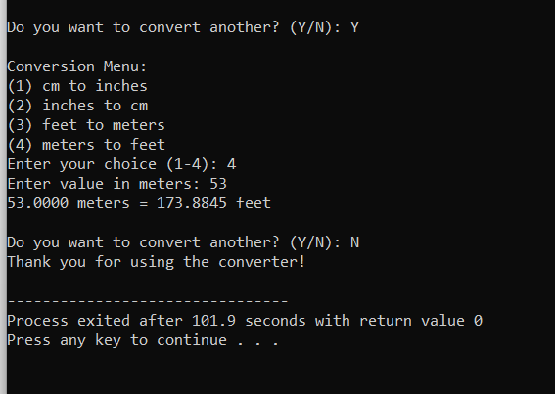

- Write a program that displays a menu for simple computation of formula such as the following:
- (1) Area of circle, will ask for radius from user
- (2) Area of rectangle, will ask for L and W
- (3) Area of triangle, will ask for B and H
- (4) Area of square - feet, will ask for S
Once selected, user will be asked to enter a float and be computed as selected. After the computation, the user would be ask to compute another until the user don't want anymore. Display your samples for all conversions
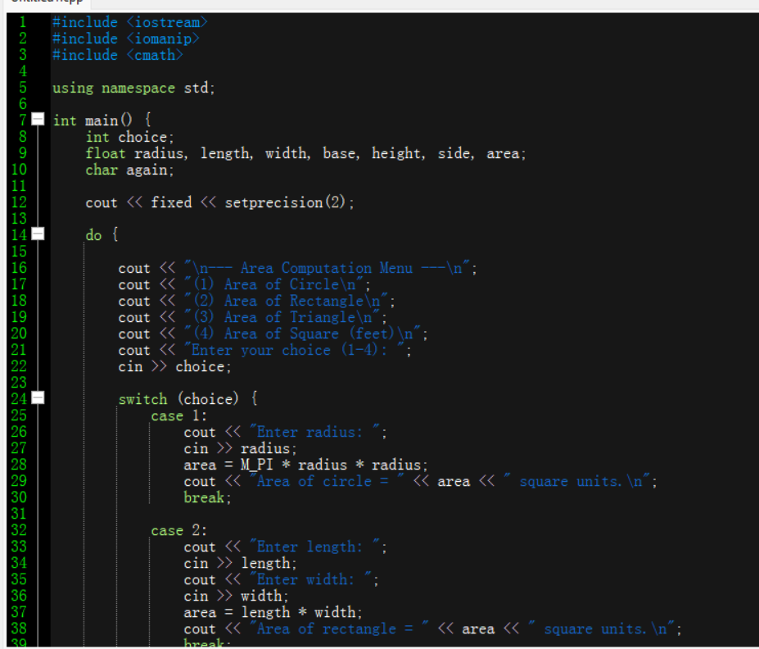

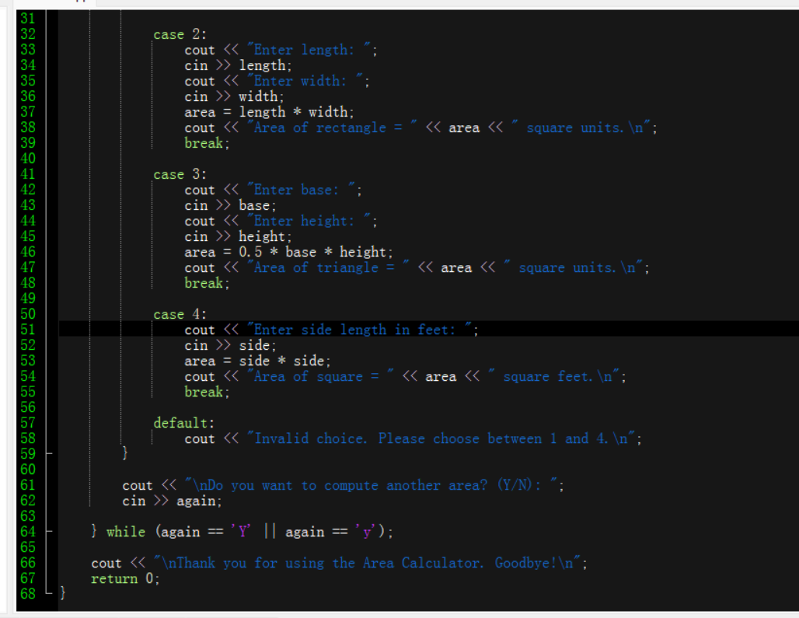

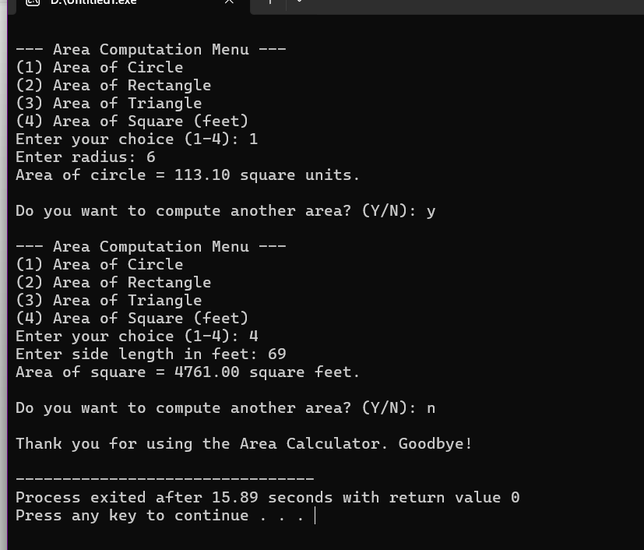
7. Supplementary Activity
8. Conclusion
It was hard to learn conditions, but with the help of some ai and google, I was about to understand coding this, coding if/else , while and repetitions. I was able to connect all my knowledge here. Some were similar to each other so it was easy when I understood it.
9. Assessment Rubric

